Living things and their habitats (environment) |  |  |  | 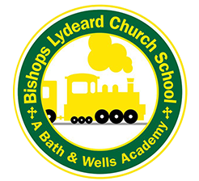
Year 5 – Year B Terms 3, 4, 5 and 6
Prior Learning  In Year 4 children should: •  - Construct and interpret a variety of food chains, identifying producers, predators and prey  - Identify that most living things live in habitats to which they are suited and describe how different habitats provide for the basic needs of different kinds of animals and plants, and how they depend on each other.  - Identify and name a variety of plants and animals in their habitats, including micro habitats. | Year 5 Learning  - Different animals mature at different rates and live to different ages.  - Some organisms reproduce sexually where offspring inherit information from both parents.  - Some organisms reproduce asexually by making a copy of a single parent.  - Environmental change can affect how well an organism is suited to its environment.  - Different types of organisms have different lifecycles. | Key Questions  - What is a life cycle? What types of life cycles are there?  - Are life cycles the same?  - Do plants reproduce in the same ways as us?  - How do plants spread their seeds? | Future Learning  In Year 6:  - Classify living things into broad groups according to observable characteristics and based on similarities and differences.  - Give reasons for classifying plants and animals based on specific characteristics.

