Forces
Year 5 – Year A Terms 1 and 2
Prior Learning  In Year 3 children should:  - Compare how things move on different surfaces.  - Know how a simple pulley works and use making lifting an object simpler  - Notice that some forces need contact between two objects, but magnetic forces can act at a distance.  - Observe how magnets attract and repel each other and attract some materials and not others.  - Compare and group together a variety of everyday materials on the basis of whether they are attracted to a magnet, and identify some magnetic materials.  - Describe magnets as having two poles.  - Predict whether two magnets with attract or repel each other, depending on which poles are facing. | Year 5 Learning  - Air resistance and water resistance are forces against motion caused by objects having to move air and water out of their way.  - Friction is a force against motion caused by two surfaces rubbing against each other.  - Some objects require large forces to make them move; gears, pulley and levers can reduce the force needed to make things move | Key Questions  - What actually is a force?  - How can a force act on an object?  - How can we see forces?  - How can we measure forces?  - How does the saltiness (salinity) of water affect the water resistance?  - How does the length of a piece of a paper helicopter’s wings affect the time it takes to fall?  - How does the changing the shape of a piece of plasticine affect water resistance?  - How does adding holes to a parachute affect the time it takes to fall?  - How does the amount/depth of tread affect the friction between a shoe and a surface?  - How can we use levers to lit more?  - What is the most effective way to move an object?  - How do see-saws work?  - Can you create a pulley system to life a given load? | Future Learning  In KS3 children will learn about:  - opposing forces and equilibrium: weight held by stretched spring or supported on a compressed surface  - forces being needed to cause objects to stop or start moving, or to change their speed or direction of motion (qualitative only) change depending on direction of force and its size.

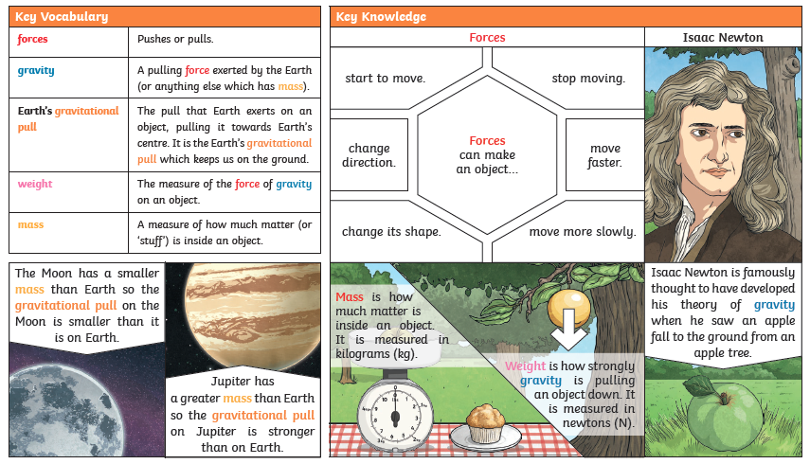

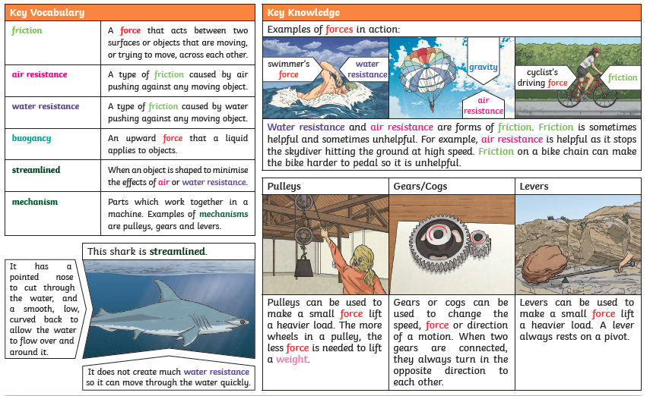

Energy

Understand that force and motion can be transferred through mechanical devices such as gears, pulleys, levers and springs.

